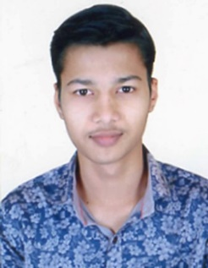**Name:** Yogesh Pirappa Hadpad.

**Contact Number: +**918975612949/918956589592.

**Email ID:** hadpady@gmail.com.

**CAREER OBJECTIVE:** To get an opportunity that allows me to showcase my skills and contribute to the organization’s growth. I am extremely motivated to constantly develop my skills and grow professionally.

**EDUCATIONAL QULAFICATION:**

|  |  |  |  |  |
| --- | --- | --- | --- | --- |
| Course | Name of Institution | University/Board | Year Of Passing | Percentage |
| B.Tech  (Electrical) | N.K.Orchid College Of Engineering And Technology | Dr.Babasaheb Ambedkar Technological universty | 2022 | Agg:-82.87% |
| H.S.C | Sangmeshwar College Of Arts And Science | Maharashtra State Board Of Education | 2018 | 61.85% |
| S.S.C | Late V.M.Mehta High School,Solapur | Maharashtra State Board Of Education | 2016 | 84.20% |

**TECHNICAL SUMMARY:**

**Technical skills:**

* Strong Understanding of **Manual Testing.**
* Excellent understanding of **Agile Methodology.**
* Hands on experience in **Selenium.**
* **API Testing** with **Postman.**
* Well familiar with **Core Java, OOPS concepts.**
* Very good knowledge of **SQL.**
* Hands on experience on **Mobile Testing.**
* **Jenkins.**
* Basic understanding of **Datadog** and **Kubernetes.**

**ACADEMIC PROJECT DETAILS:**

**Title:** **Design and Testing of car showroom management system.**

* Did the testing of car showroom management system by designing test cases.
* Performed execution of test cases by automation tools like selenium.
* Performed smoke, sanity, functional, ad-hoc Testing.
* Used different test case design techniques.

**CO-CURRICULAR ACTIVITIES:**

* Attended Student Excellence & Learning Program (SELP) under ART OF LIVING at N.K.Orchid College.
* Servered as a cultural head in department events.
* Participated in college sport event.
* Participated in drawing competition in college evets.

**PERSONAL DETAILS:**

**Date Of Birth:**29/02/2000.

**Languages Known:** Marathi, Hindi ,English.

**Hobbies:** Portrait Drawing, Cooking, Watching Movies.

**Permanent Address**: 180 ,Raghvendra nagar Vijapur Road jule Solapur, Solapur. 413004.